React App - FlyGift (Group number 4)
Software Design Document

Names: Roni Pick, Arik Tatievski, Roi Meshulam, Liroy Melamed
Date: 01/11/2023
TABLE OF CONTENTS
1. INTRODUCTION ………………………………………..…………………...…………………….. 3
1.1 Purpose ……………………………………..………………………………………….. 3
1.2 Scope ………...………………………….………..…………………………………….. 3
1.3 Overview ….………………………………..…..………………..…………………….. 3
1.4 Reference Material ….……………………..……..…………...………………….. 4
1.5 Definitions and Acronyms ….……………..………...………………………….. 4
2. SYSTEM OVERVIEW ..…………….….…………………...…………..……………………….. 5
3. SYSTEM ARCHITECTURE …………….….…………………...…………….….……………… 6
3.1 Architectural Design …………….….…………………...…………….….………. 6
3.2 Decomposition Description …………….….…………………...…………….… 7
3.3 Design Rationale …………….….…………………...…………….….…………….. 7
4. DATA DESIGN …………….….…………………...…………….….…………………...………… 8
4.1 Data Description ………………...…………….….…………………………………. 8
4.2 Data Dictionary ………………...…………….….…………………………………... 8
5. COMPONENT DESIGN …...…………….….………………………...…………….….………… 9
6. HUMAN INTERFACE DESIGN …...…………….….………………………...……………... 10
7. REQUIREMENTS MATRIX ………….….…………………...………………….….………… 13
8. APPENDICES ………….….…………………...………………….….…………………...……… 14
1.INTRODUCTION
1.1 Purpose
This software design document describes the architecture and system design of our application that is interfacing a search engine, payment APIs with an easy and reliable client and admin use.
1.2 Scope
Our product will provide a new service which does not exist. An application that allows employers to buy a gift card which will improve the employees morale and lead to a more loyal, better working employee.
from the employees point of view a comfortable, reliable and easy to use application to:
- receive the gift
- use it to search for the best flight
- buy the flight ticket
- save points for the future.
1.3 Overview
Employers wish to match the holiday gifts for employees, despite the attempts, 77% are not satisfied from the gifts.
60% of holiday gift recipients would prefer to receive a plane ticket.
We want to take over the “Gift Cards” business by creating a new type of gift card that is not only desired by employers but also gives them a comfortable platform to exploit the gift card on.
Features & Technology
- React JS application.
- Database.
- Client side capable of saving data safely.
- Admin side capable of full control of clients data.
- Flight search engine.
- Payment API.
- SMS confirmation API.
- Mail confirmation API.

1.4 Reference Material
Payment API
https://www.youtube.com/watch?v=IhvtIbfDZJI&ab_channel=StripeDevelopers
https://www.youtube.com/watch?v=XRt34VBPInE&ab_channel=MichaelKitas
Email Sending API
https://www.youtube.com/watch?v=nF9g1825mwk&ab_channel=TraversyMedia
SkyScanner API
https://github.com/bartkalanski/flight-search-react
https://skyscanner.github.io/slate/#api-documentation
https://rapidapi.com/blog/skyscanner-api-overview/#:~:text=How%20much%20does%20an%20API,and%20allows%20for%20unlimited%20calls.
1.5 Definitions and Acronyms
Search engine – we combine the term search engine in the usage of our application. By saying search engine, we mean search flights and also the ability to buy them.
Payment API – an API we are using to make valid and trusted payments over internet.
Application – a react app including client dashboard and admin dashboard.

2. SYSTEM OVERVIEW
Our application will authenticate users through the database transferring them to the relevant portal.
Users portal will be able to use Flight Search Engine, Secure Payment and Email Validation APIs that are already implemented on the portal.
So if we try to break down the functionality to the simplest way it will look like this:
User -> Authentication -> Validation Token -> Connects to his personal
data -> Opens User Portal -> Being able to use all the functionality of our app.
3. SYSTEM ARCHITECTURE
3.1 Architectural Design
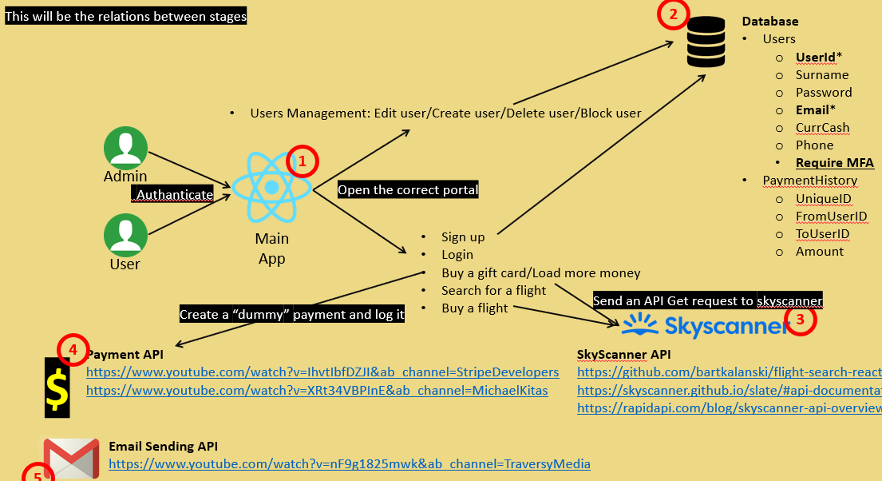
An easy explanation:
- Users/Admins will “connect” to our application with authentication. (Opens the possibility to enter the relevant portal)
- * Admins will be able only to manage users (deleting/blocking/editing..)
* Users will be able to use all our application functionality
- Searching for flights using Skyscanner API (Collecting the variables needed to make an API request from the portal)
- Paying and updating the user’s data with a payment API (Collecting the variables needed to make an API request from the portal)
- Email sending API to confirm a purchase.(After a payment was made we will send a validation email).
3.2 Decomposition Description
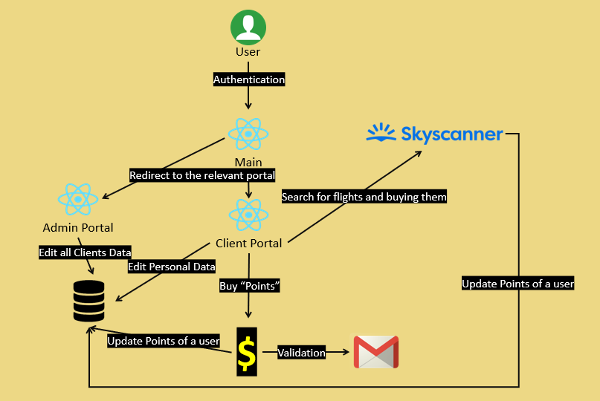
3.3 Design Rationale
We’ve tried to module our application as much as we could.
Our database includes only 2 fields which are important for the entire project:
- Users – to supervise and get data on each of our users
- Payment History – to save all the transactions that we made
We have 2 portals (Admin & User) that you can enter each of them only after authentication.
You can manage your entire user & functions from 1 simple dashboard and we don’t need to create any others.
4. DATA DESIGN
4.1 Data Description
We will be using a UI (React) to accept data from the user, transform it to the backend to structure it as a list (using JavaScript) and send it to the database(Firebase).
Any communication with the database will be with lists containing the relevant data.
Example: write(db,’Users/){Name: Arik, Email: Arik@Arik.com …}
We will be using a UI (React) to accept data from the user, transform it to the backend to structure it as an object (using javascript) and send it to the API(SkyScanner/Email Validation/Credit Card Company).
Any communication with the APIs will be using the API’s requested structure as an API GET request.
Example: get(API,AllFlights/){Src: BNG, Dest:MAD, Src Date: 21/06/23 …}
We wont be using any other data structure.
4.2 Data Dictionary
Bold* - primary key. What comes after – is the data type.
- Users - list
  - UserId* - uid
  - Surname - string
  - Password - string
  - Email* - mail
  - CurrCash - double
  - Phone – integer
- PaymentHistory - list
  - UniqueID* - uid
  - FromUserID - uid
  - ToUserID - uid
  - Amount – double
5. COMPONENT DESIGN
Since our application is a React application we will complete this section with the proper terms.
App.js – this will be our “welcoming” page and we will be able to log in from here.
- AdminPortal.js – the main portal for admins.
  - Navigation.js – the navigation bar between all the Admin’s possible actions.
  - Preview.js – what we will be previewing depending
  - There will be more components under the Admin Portal, but it will be “dummy” simple components.
- UserPortal.js – the main portal for admins.
  - Navigation.js – the navigation bar between all the Admin’s possible actions.
  - Preview.js – what we will be previewing depending
  - SkyScanner.js – the component to create and make the API requests to skyscanner
  - Payment.js - the component to create and make the API requests to the credit card company
    - EmailValidation.js – after payment is accepted the component to create and make the API requests to the email sending.
6. HUMAN INTERFACE DESIGN
We will combine all these section to one main section:
Signin\log in:
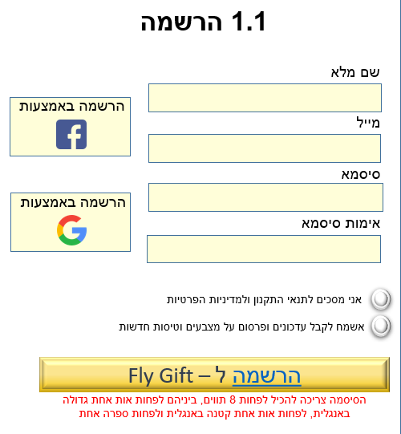
Main page:
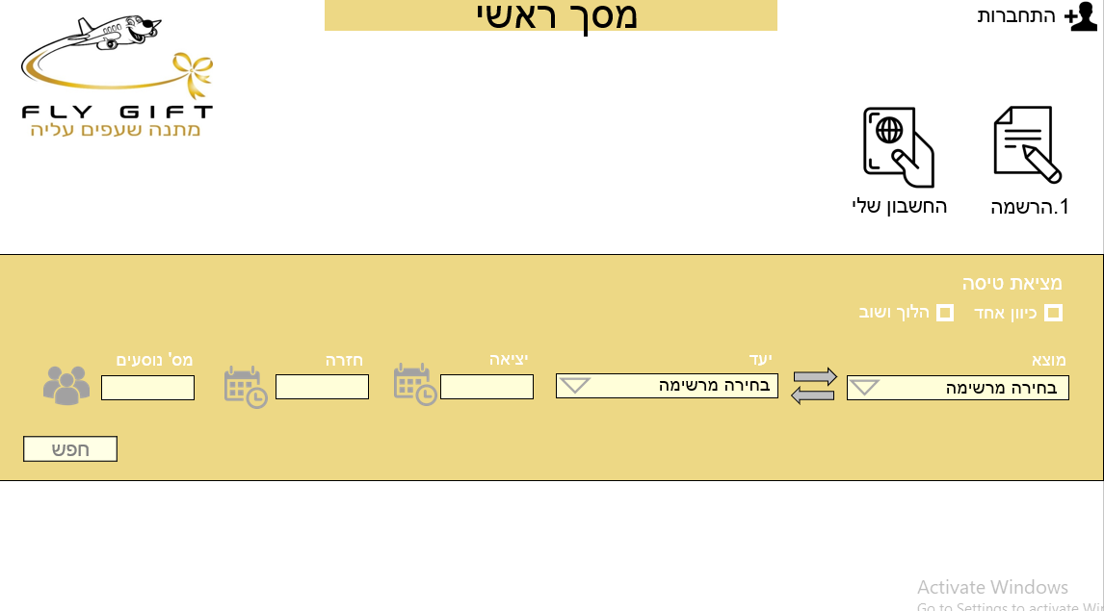
Search a flight:
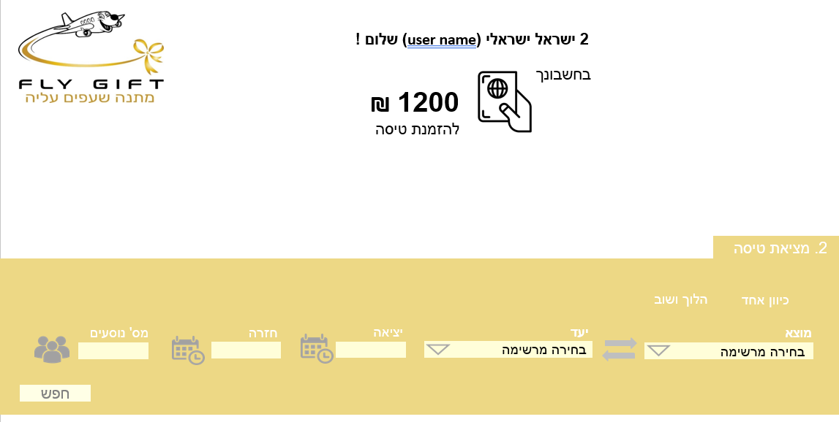
Flights resaults:
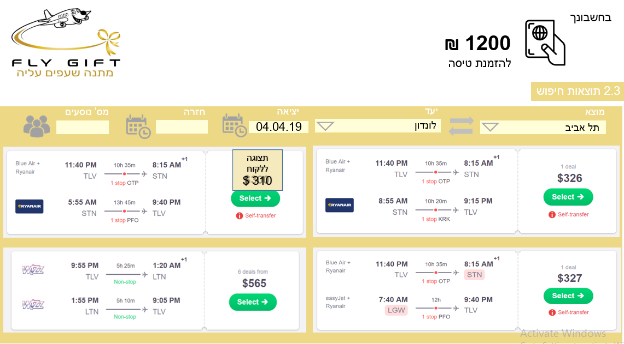
By pressing "Select" – payment page:
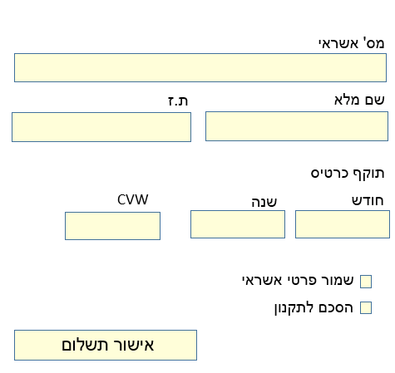

7. REQUIREMENTS MATRIX
הרחבה | תיעדוף (גבוהה/נמוך) | תת סוג | סוג  (פונקציונאלית/  לא פונקציונאלית) | תיאור | מס' מזהה
 | נמוכה | תאימות לכל המסכים | לא פונקציונלי | שיתאים לכל סוגי המסכים – טאבלטים/פלאפונים/WEB | 1
 | גבוהה | אמינות | לא פונקציונלי | רק מנהל יכול לערוך מידע של משתמש ללא קשר למי המשתמש | 2
 | נמוכה | יעילות ביצועים | לא פונקציונלי | זמן טעינה של טיסות | 3
 | גבוהה | שימושיות | לא פונקציונלי | הממשק צריך להיות פשוט ונוח לשימוש | 4
 | גבוהה | אמינות | לא פונקציונלי | העבודה היא מול Firebase ולא מול ספק חזק ואמין | 5
הפרדה מוחלטת בממשק בין צפייה בנתונים לעריכת נתונים | גבוהה | דרישת תפעולית | פונקציונלי | כניסה נפרדת למנהל וללקוח | 6
 | נמוכה | דרישת מידע | פונקציונלי | הוספת מנהל ולקוח למערכת | 7
 | נמוכה | דרישת מידע | פונקציונלי | קניית טיסה | 8
על מנת למנוע כפילויות בDATABASE | נמוכה | דרישת מידע | פונקציונלי | ID שונה לרכישות שונות | 9
צ'אט פעיל בין מנהל ללקוח | גבוהה | דרישת מידע | פונקציונלי | שליחת הודעה למנהל (צור קשר) | 10
8. APPENDICES
Payment API
https://www.youtube.com/watch?v=IhvtIbfDZJI&ab_channel=StripeDevelopers
https://www.youtube.com/watch?v=XRt34VBPInE&ab_channel=MichaelKitas
Email Sending API
https://www.youtube.com/watch?v=nF9g1825mwk&ab_channel=TraversyMedia
SkyScanner API
https://github.com/bartkalanski/flight-search-react
https://skyscanner.github.io/slate/#api-documentation
https://rapidapi.com/blog/skyscanner-api-overview/#:~:text=How%20much%20does%20an%20API,and%20allows%20for%20unlimited%20calls.

